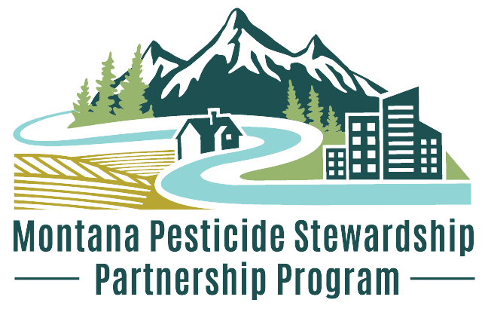
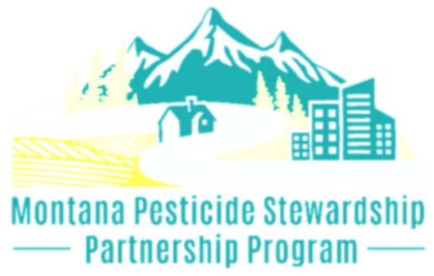
Pesticide Stewardship Partnership Program
Flathead Lake Biological Station
University of Montana
Competitive Contract Application

Applicant Information
Date of Application: Click to enter text.

Organization: Click to enter text.
Address: Click to enter text.
Website: Click to enter text.

Person of Contact: Click to enter text.
Email: Click to enter text.
Phone: Click to enter text.

Contract Agreement Signee: Click to enter text.
(if different than Person of Contact)
Email: Click to enter text.
Phone: Click to enter text.

Project Title: Click to enter text.
Location of Project: Click to enter text.

Contract Amount Requested: Click to enter text.
Cost Match Amount: Click to enter text.

Start and End Dates: Click to enter text.
Introduction + Past Work
Provide a brief history of your organization, its mission, and past achievements. Highlight any relevant experience that demonstrates your capability to successfully complete the proposed project. Maximum 400 words.
Click to enter text.
Overview: Goals, Objectives, and Outcomes
Please provide a detailed summary of your proposed project. Your summary should include the overarching goals, specific measurable objectives, paired activities, and anticipated outcomes. Additionally, include anticipated completion dates (Month-Year) for each activity.
- Goals: Clearly state the overall goals of your project. What do you aim to achieve? Maximum 150 words.
- Objectives: Outline the specific, measurable objectives for each goal. Maximum 150 words.
- Activities and Timeline: Describe the key activities needed to achieve each objective. Include details on how these activities will be implemented, who will be responsible for each task, and the anticipated completion dates. Maximum 250 words.
- Outcomes: Explain the expected outcomes of your project. What are the anticipated short-term and long-term impacts? How will these outcomes contribute to reducing pesticide use and/or pesticide pollution in surface waters? Maximum 150 words.
Please provide the information below. Please note, there is no requirement for the total number of goals. If additional space is needed, please copy and paste the formatting to add more goals, objectives, or activity lines.
Goal #1: [Your goal here]
Objectives:
- [Your objective here]
- [Your objective here]
Activities and Timeline:
- Activity: [Describe activities to achieve objective 1 here]
  - Specific Tasks: Click to enter text.
  - Responsible Party: Click to enter text.
  - Anticipated Completion Date: Click to enter text.
- Activity: [Describe activities to achieve objective 2 here]
  - Specific Tasks: Click to enter text.
  - Responsible Party: Click to enter text.
  - Anticipated Completion Date: Click to enter text.
Goal #1 Outcomes: [Your outcomes here]
Goal #2: [Your goal here]
Objectives:
- [Your objective here]
- [Your objective here]
Activities and Timeline:
- Activity: [Describe activities to achieve objective 1 here]
  - Specific Tasks: Click to enter text.
  - Responsible Party: Click to enter text.
  - Anticipated Completion Date: Click to enter text.
- Activity: [Describe activities to achieve objective 2 here]
  - Specific Tasks: Click to enter text.
  - Responsible Party: Click to enter text.
  - Anticipated Completion Date: Click to enter text.
Goal #2 Outcomes: [Your outcomes here]
The Project
Explain the potential benefits of the project for water quality, aquatic ecosystems, and/or human health. Outline the specific approaches, methods, or activities planned to achieve the project goals. List the key personnel involved in the project, along with their qualifications and relevant experience. Specify the geographic area within the Columbia River Basin the project will serve. Explain how stakeholders may be engaged in the project through input, collaboration, or outreach. Maximum 600 words.
Click to enter text.
Measuring Success
Explain expected results and how you will measure success/effectiveness of your activities. Specify the quantitative and qualitative metrics you will use to measure success. Provide a detailed plan outlining how you will monitor and evaluate progress. This can be supported by the required quarterly reports. If applicable, how do you plan to sustain your outcomes beyond the funding period? Maximum 300 words.
Click to enter text.
Budget + Cost Match
Outline necessary expenditures using budget categories which must align with invoice categories for reimbursement purposes. Per the Contract Guidelines, 25% of total project cost must be cost match and cannot be federally sourced. For example, if you are requesting $7,500, your required cost match would be $2,500 (functionally, 1/3 of your requested funding). See example below:
Requested Funding + Cost Match = Total Project Cost
$7,500 + $2,500 = $10,000
75% + 25% = 100%
Budget Category | Requested Funding $ | Cost Match $
Click to enter text. | Click to enter amount. | Click to enter amount.
Click to enter text. | Click to enter amount. | Click to enter amount.
Click to enter text. | Click to enter amount. | Click to enter amount.
Click to enter text. | Click to enter amount. | Click to enter amount.
Click to enter text. | Click to enter amount. | Click to enter amount.
Click to enter text. | Click to enter amount. | Click to enter amount.
Click to enter text. | Click to enter amount. | Click to enter amount.
Click to enter text. | Click to enter amount. | Click to enter amount.
Click to enter text. | Click to enter amount. | Click to enter amount.
Total Project Cost= | 0 | 0

Budget Justification
In a paragraph, provide a budget justification explaining how funds will be used and how you plan to meet Cost Match requirements. Describe how the project is practical and achievable within the budget. Maximum 200 words.
Click to enter text.
Submit Application
Email your application and any supporting documents to the PSPP Research Coordinator:
Janelle Groff
janelle.groff@flbs.umt.edu
406-872-4508

